

**Faculty of engineering - Shoubra Benha University**

**Research Project**

In fulfillment of the requirements of

|  |  |
| --- | --- |
| **Department** | **Engineering Mathematics and Physics** |
| **Division** | **-----------** |
| **Academic Year** | **2020-2021 Preparatory** |
| **Course name** | **Computer** |
| **Course code** | **ECE001** |

**Title: -**

Build a website on recent computer engineering topics ( **Artificial intelligence** )

**Made by :**

|  |  |
| --- | --- |
| **Student name :** | **Abdelmajeed Azab Abdelmajeed** |
| **Seat number :** | **494** |

**Examiners committee**

|  |  |
| --- | --- |
| 1 | Dr.Ahmed Bayoumi |
| 2 | Dr.Shady Elmashad |
| 3 | Dr. Abdelhamid Attaby |

**Artificial Intelligence (AI)**

**Definition**

Artificial intelligence (AI) is a wide-ranging branch of computer science concerned with building smart machines[1] that are programmed to think like humans and mimic their actions[2]. AI is an interdisciplinary science with multiple approaches[1]. The term can also refer to any machine that exhibits traits associated with a human mind such as learning and problem-solving.[2]

**History of AI**

Intelligent robots and artificial beings first appeared in the ancient Greek myths of Antiquity. While the roots are long and deep, the history of artificial intelligence as we think of it today spans less than a century. The following is a quick look at some of the most important events in AI.

|  |  |
| --- | --- |
| **1943**  Warren McCullough and Walter Pitts publish "A Logical Calculus of Ideas Immanent in Nervous Activity." The paper proposed the first mathematic model for building a neural network. | **1974-1980**  Frustration with the progress of AI development leads to major DARPA cutbacks in academic grants. Combined with the earlier ALPAC report and the previous year's "Lighthill Report," artificial intelligence funding dries up and research stalls. This period is known as the "First AI Winter." |
| **1949**  In his book The Organization of Behavior: A Neuropsychological Theory, Donald Hebb proposes the theory that neural pathways are created from experiences and that connections between neurons become stronger the more frequently they're used. Hebbian learning continues to be an important model in AI. | **1980**  Digital Equipment Corporations develops R1 (also known as XCON), the first successful commercial expert system. Designed to configure orders for new computer systems, R1 kicks off an investment boom in expert systems that will last for much of the decade, effectively ending the first "AI Winter." |
| **1950**  Alan Turing publishes "Computing Machinery and Intelligence, proposing what is now known as the Turing Test, a method for determining if a machine is intelligent.  Harvard undergraduates Marvin Minsky and Dean Edmonds build SNARC, the first neural network computer.  Claude Shannon publishes the paper "Programming a Computer for Playing Chess."  Isaac Asimov publishes the "Three Laws of Robotics." | **1982**  Japan's Ministry of International Trade and Industry launches the ambitious Fifth Generation Computer Systems project. The goal of FGCS is to develop supercomputer-like performance and a platform for AI development. |
| **1952**  Arthur Samuel develops a self-learning program to play checkers. | **1983**  In response to Japan's FGCS, the U.S. government launches the Strategic Computing Initiative to provide DARPA funded research in advanced computing and artificial intelligence. |
| **1954**  The Georgetown-IBM machine translation experiment automatically translates 60 carefully selected Russian sentences into English. | **1985**  Companies are spending more than a billion dollars a year on expert systems and an entire industry known as the Lisp machine market springs up to support them. Companies like Symbolics and Lisp Machines Inc. build specialized computers to run on the AI programming language Lisp. |
| **1956**  The phrase artificial intelligence is coined at the "Dartmouth Summer Research Project on Artificial Intelligence." Led by John McCarthy, the conference, which defined the scope and goals of AI, is widely considered to be the birth of artificial intelligence as we know it today.  Allen Newell and Herbert Simon demonstrate Logic Theorist (LT), the first reasoning program. | **1987-1993**  As computing technology improved, cheaper alternatives emerged and the Lisp machine market collapsed in 1987, ushering in the "Second AI Winter." During this period, expert systems proved too expensive to maintain and update, eventually falling out of favor.  Japan terminates the FGCS project in 1992, citing failure in meeting the ambitious goals outlined a decade earlier.  DARPA ends the Strategic Computing Initiative in 1993 after spending nearly $1 billion and falling far short of expectations. |
| **1958**  John McCarthy develops the AI programming language Lisp and publishes the paper "Programs with Common Sense." The paper proposed the hypothetical Advice Taker, a complete AI system with the ability to learn from experience as effectively as humans do. | **1991**  U.S. forces deploy DART, an automated logistics planning and scheduling tool, during the Gulf War. |
| **1959**  Allen Newell, Herbert Simon and J.C. Shaw develop the General Problem Solver (GPS), a program designed to imitate human problem-solving.  Herbert Gelernter develops the Geometry Theorem Prover program.  Arthur Samuel coins the term machine learning while at IBM.  John McCarthy and Marvin Minsky found the MIT Artificial Intelligence Project. | **1997**  IBM's Deep Blue beats world chess champion Gary Kasparov |
| **1963**  John McCarthy starts the AI Lab at Stanford. | **2005**  STANLEY, a self-driving car, wins the DARPA Grand Challenge.  The U.S. military begins investing in autonomous robots like Boston Dynamic's "Big Dog" and iRobot's "PackBot." |
| **1966**  The Automatic Language Processing Advisory Committee (ALPAC) report by the U.S. government details the lack of progress in machine translations research, a major Cold War initiative with the promise of automatic and instantaneous translation of Russian. The ALPAC report leads to the cancellation of all government-funded MT projects. | **2008**  Google makes breakthroughs in speech recognition and introduces the feature in its iPhone app. |
| **1969**  The first successful expert systems are developed in DENDRAL, a XX program, and MYCIN, designed to diagnose blood infections, are created at Stanford. | **2011**  IBM's Watson trounces the competition on Jeopardy!. |
| **1972**  The logic programming language PROLOG is created. | **2012**  Andrew Ng, founder of the Google Brain Deep Learning project, feeds a neural network using deep learning algorithms 10 million YouTube videos as a training set. The neural network learned to recognize a cat without being told what a cat is, ushering in breakthrough era for neural networks and deep learning funding. |
| **1973**  The "Lighthill Report," detailing the disappointments in AI research, is released by the British government and leads to severe cuts in funding for artificial intelligence projects. | **2014**  Google makes first self-driving car to pass a state driving test. |
| **2016**  Google DeepMind's AlphaGo defeats world champion Go player Lee Sedol. The complexity of the ancient Chinese game was seen as a major hurdle to clear in AI. | |

[1]

**Categories of Artificial Intelligence**

Artificial intelligence can be divided into two different categories: weak and strong.

**Narrow AI**

( Sometimes referred to as "Weak AI")

 Include a system designed to carry out one particular job. Weak AI systems include video games such as the chess example from above and personal assistants such as Amazon's Alexa and Apple's Siri. You ask the assistant a question, it answers it for you [1,2].

**Artificial General Intelligence (AGI):**

( AGI, sometimes referred to as "Strong AI")

It is the kind of artificial intelligence we see in the movies, like the robots from West world or Data from Star Trek: The Next Generation. AGI is a machine with general intelligence and, much like a human being, These tend to be more complex and complicated systems , it can apply that intelligence to solve any problem. These kinds of systems can be found in applications like self-driving cars or in hospital operating rooms[1, 2].

**Applications of Artificial Intelligence**

The applications for artificial intelligence are endless. The technology can be applied to many different sectors and industries. AI is being tested and used in the healthcare industry for dosing drugs and different treatment in patients, and for surgical procedures in the operating room.

Other examples of machines with artificial intelligence include computers that play chess and self-driving cars. Each of these machines must weigh the consequences of any action they take, as each action will impact the end result. In chess, the end result is winning the game. For self-driving cars, the computer system must account for all external data and compute it to act in a way that prevents a collision.

Artificial intelligence also has applications in the financial industry, where it is used to detect and flag activity in banking and finance such as unusual debit card usage and large account deposits—all of which help a bank's fraud department. Applications for AI are also being used to help streamline and make trading easier. This is done by making supply, demand, and pricing of securities easier to estimate.[2]

**AI Examples**

* Smart assistants (like Siri and Alexa)
* Disease mapping and prediction tools
* Manufacturing and drone robots
* Optimized, personalized healthcare treatment recommendations
* Conversational bots for marketing and customer service
* Robo-advisors for stock trading
* Spam filters on email
* Social media monitoring tools for dangerous content or false news
* Song or TV show recommendations from Spotify and Netflix

[1]

**Risks of Artificial Intelligence**

* Automation-spurred job loss
* Privacy violations
* 'Deepfakes'
* Algorithmic bias caused by bad data
* Socioeconomic inequality
* Weapons automatization

[3]

**References**

[1] <https://builtin.com/artificial-intelligence>

[2] <https://www.investopedia.com/terms/a/artificial-intelligence-ai.asp>

[3] <https://builtin.com/artificial-intelligence/risks-of-artificial-intelligence>

**My Website link**

<https://abdelmagid-orabi.github.io/ece001/>

**Website Screenshots**

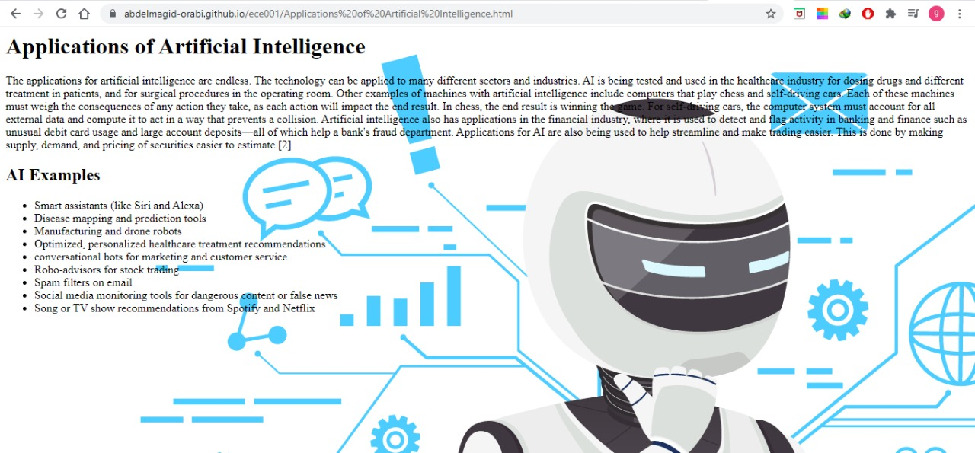

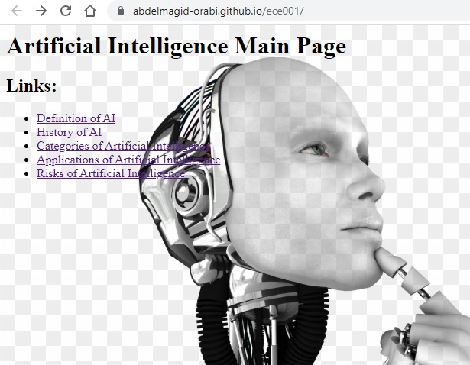

**Source Code**

